1. Calendar

Calendar has 2 basic function

1. Reminder of due process : payment, anuallity, (repeatable process), and notes reminder
2. Marked the use of asset in certain date use in the transaction. When the asset is marked it shows in calendar and can not be assigned in the transaction on the respective dates.

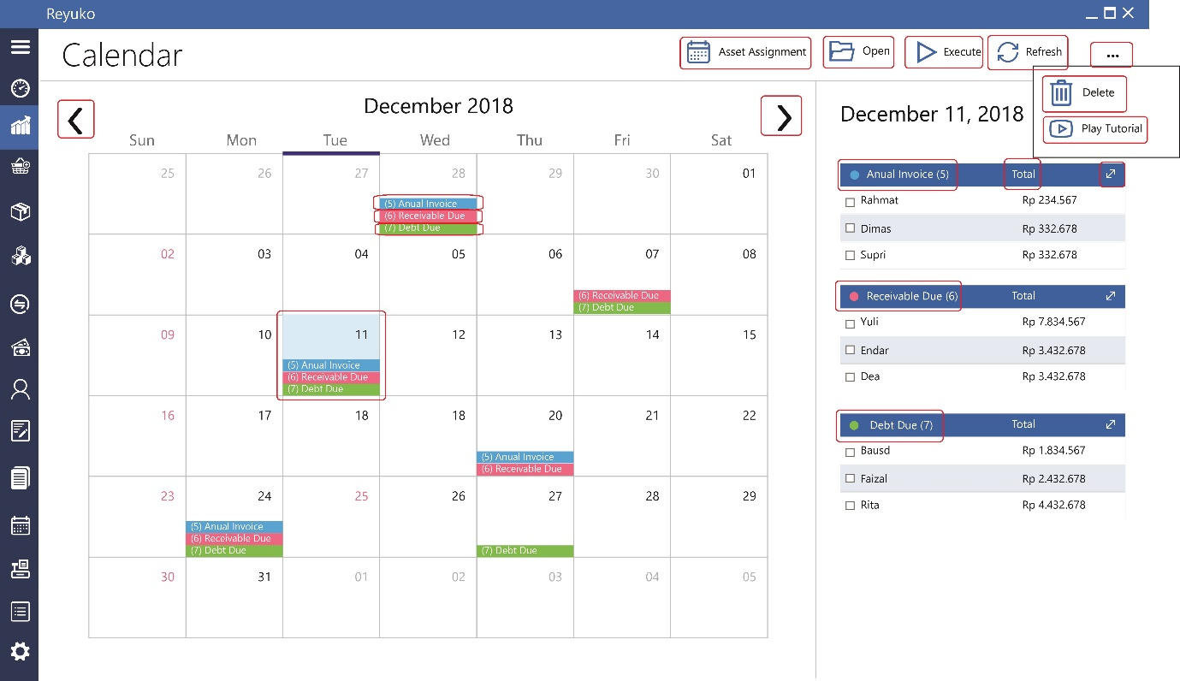­­­­­

16

15

B

A

14

13

12

11

10

9

8

7

6

5

4

3

2

1

1. Button “asset assignment”, : There are 2 kind of calendar, normal calendar above which display a pending item of the transaction, and there are schedule of service which using asset for service to operate (eg: room hotel, car rental).
2. Button “open”, Open button function is to open native form certain transaction which being highlited, this function can be also represent by using doble click
3. Button “execute”, is batch process of everything being highlighted in their native transaction (eg, annual invoice: will produce an invoice base on the creteria). The execute button only works if the selected item in the same category (eg: annual invoice)
4. Button “refresh”, to referesh calendar after execution has taken place.
5. Button “…”, more menu
6. Button “delete”, delete item on the calendar change status from 0 to 2.
7. Button “play tutorial”, Play tutorial respective calendar function, Pop up and Youtube link
8. Button “left arrow”, go to previous monht
9. Button “right arrow”, go to next month
10. Mark “ blue”, label for annual invoice, this is set by setting anualiti on the invoice (eg: membership, annual fee, etc). The number respresent how many annual invoce pending on the respective date.
11. Mark “red”, label for receivable due, this is set by “payment module” which indicate due date of receivable. The number respresent how many receivable due on the respective date.
12. Mark “green”, label for payable due, this is set by “payment module” which indicate due date of payable due. The number respresent how many receivable due on the respective date.

Mark “Yellow” (not in the sample above), label for annual receive good, this is set by setting anualiti on the purchase order . The number respresent how many annual receive good pending on the respective date.

1. Mark “square blue”, represent current date

informasi tabel

1. Kolom “annual invoice” : detailed version of invoice, the list will be limted to 5, more than 5 people need to expand to pop up full menu

14A. kolom “total” : the amount of respective pending transaction

14B. kolom/sign “expand” : pop up to full form of respective categories as 1.1 calendar (expand)

1. kolom “receivable due” : list of the receivable due, the list will be limted to 5, more than 5 people need to expand to pop up full menu
2. kolom “debit (Payable) due” : list of the debit (payable) due, the list will be limted to 5, more than 5 people need to expand to pop up full meny

16 A. ( Not in picture) Annual Receive Goods

Table

|  |  |
| --- | --- |
| id_kalender | Id of the calendar record - unique |
| Calendar_type | 0 or 1, 0 is standar calendar, 1 is asset assignment calendar |
| tanggal | Due date record |
| Id_transaksi | Id of transaction_calendar which creates due date on the calendar. There are 3 type of orgination : modul_Hutang&piutang table and invoice/receive_good table (and other repeatable process) and notes reminder |
| Id _transaksi_referal | Store includes from Id_transaksi, there are 2 type : modul_Hutang&piutang wil use id_origin, invoice/receive_good table will use id_transaksi |
| Id_nomor_transaksi | Store includes from Id_transaksi (related to Id_transaksi_referal) |
| id_kontak | Store includes from Id_transaksi |
| keterangan | Store includes from Id_transaksi |
| id_employee | Store includes from Id_transaksi |
| id_user_id | Store includes from Id_transaksi |
| id_lokasi | Store includes from Id_transaksi |
| id_proyek | Store includes from Id_transaksi |
| id_departemen | Store includes from Id_transaksi |
| id_Asset |  |
| Id_Asset Category |  |
| value | Store includes from Id_transaksi |
| Status | 0=Open (current display), 1 = Done (stike through), 2= delete (hide) |

Note : every change on original form (id_transaksi), will triger re-store to the calendar, including deleting the item on the calendar.

1.1. Calendar (expand)

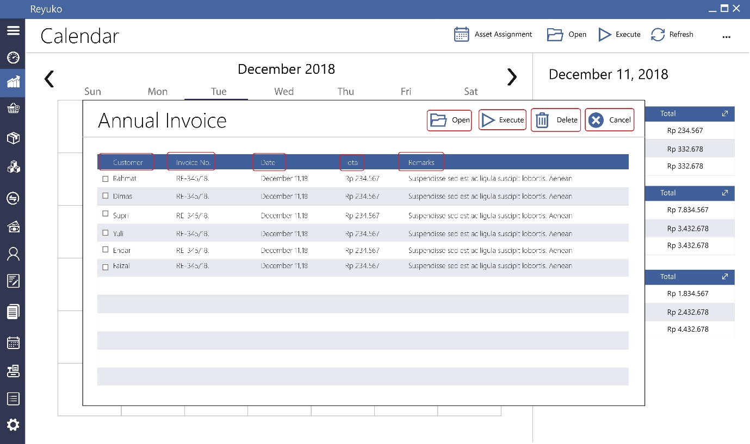

9

8

7

6

5

4

3

2

1

1. Button “open”, same with main form
2. Button “execute”, same with main form
3. Button “delete”, same with main form
4. Button “cancel”, close the pop up

Pop Up Information :

1. kolom “customer” : customer name, from id_kontak
2. kolom “Refferal” : transaction number from Invoice / order received and transaction number id_transaksi origin from modul_Hutang&piutang table and reminder from notes
3. kolom “date” : date of due or annual
4. kolom “total” : value colom
5. kolom “remark” : keterangan colom

1.2. Calendar (asset assignment) switch to asset assignment calendar, Calendar_type=1

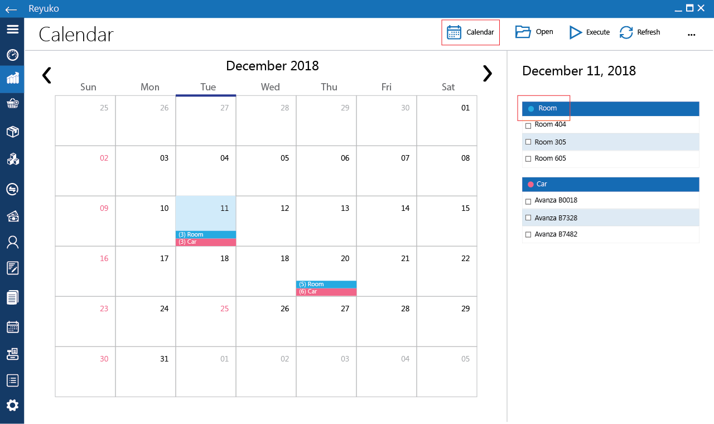

1

1. Button “calendar”, Go back to normal calendar
2. “Room” is asset category with color randomly assign by system.

Asset assignment is calendar type 0 which put by invoice modul from order jasa jual table, the objective of this calendar is for marking which asset being used or rent on the respective date

All the calendar table field wiil be fill from invoice table and order jasa jual table with the calendar type=1. All the data will be hidden except the asset name on the specific date

The calendar table will fill as follow :

|  |  |
| --- | --- |
| id_kalender | Id of the calendar record - unique |
| Calendar_type | 0 or 1, 0 is standar calendar, 1 is asset assignment calendar |
| tanggal | delivery/start date from oder_jasa_jual table |
| Id_transaksi | id_transaksi from invoice table |
| Id _transaksi_referal |  |
| Id_nomor_transaksi | no_invoice related to id_transaksi from invoice table |
| id_kontak | Store includes from Id_transaksi from invoice table |
| keterangan | Store includes from Id_transaksi from invoice table |
| id_employee | Store includes from Id_transaksi from invoice table |
| id_user_id | Store includes from Id_transaksi from invoice table |
| id_lokasi | Store includes from Id_transaksi from invoice table |
| id_proyek | Store includes from Id_transaksi from invoice table |
| id_departemen | Store includes from Id_transaksi from invoice table |
| id_Asset | Store includes from Id_transaksi from invoice table |
| Id_Asset_Category | From asset category related to Id_aset |
| value |  |
| Status | 0=Open (current display) |

2.1. Document Type

This document type is simple categories for document. Document it self is a group of 4 attach files. The porpose of this document is managing digital document of the customer

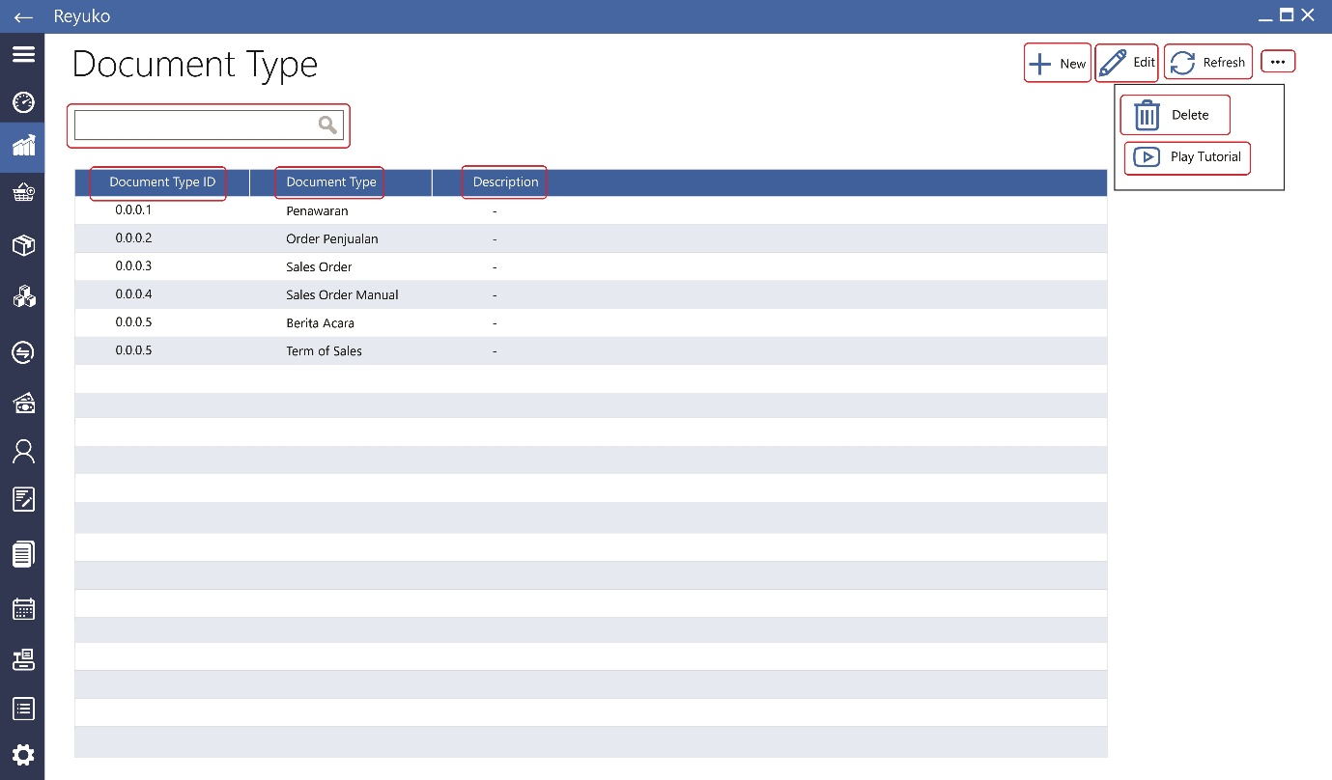

10

9

8

7

6

5

4

3

2

1

1. Field “search”, to search document type – optional, can be removed if difficult
2. Button “new”, to create new document type
3. Button “edit”, to edit document type property
4. Button “refresh”, to refresh the list after certain action, can be removed if unnecessary in the program
5. Button “…”, more menu
6. Button “delete”, delete document type, can be done if the there are no document assign to respective document type
7. Button “play tutorial”, play related video tutorial

Table Information

1. kolom “document type id” : id of document, auto create 4 digit start with 0 (no need dot (.) between number)
2. kolom “document type” : type of document – document categories
3. kolom “description” : description of categroies

2.2. Document Type (Create new)

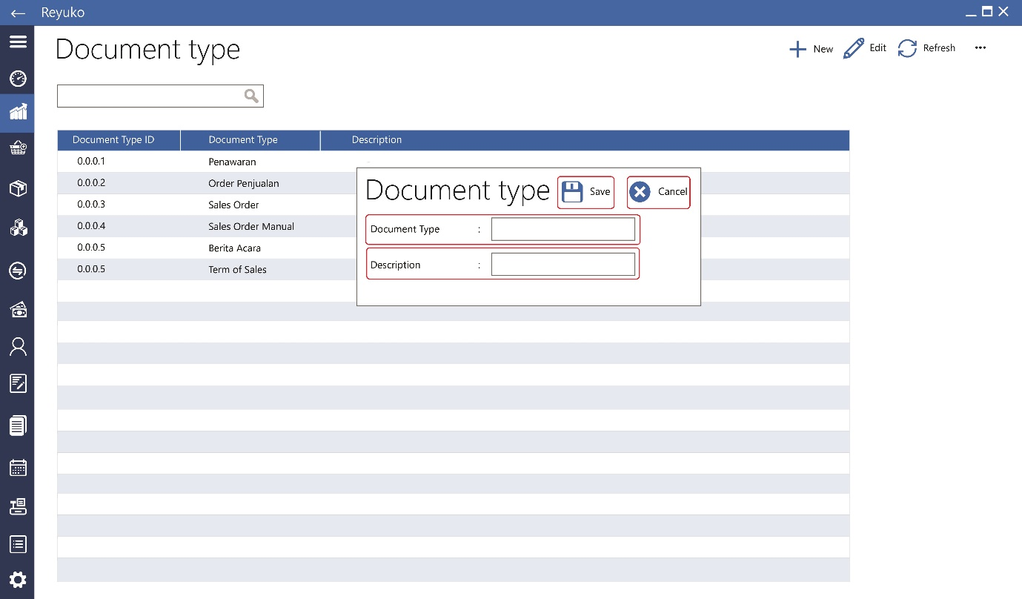

4

3

2

1

1. Button “save”, save data
2. Button “cancel”, abort process
3. Field “document type”, type of document – document categories
4. Field “description”, description of document categroies

Table structure is straight forwad :

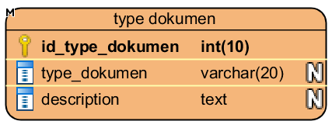

4

3

2.3. Document Type (delete)

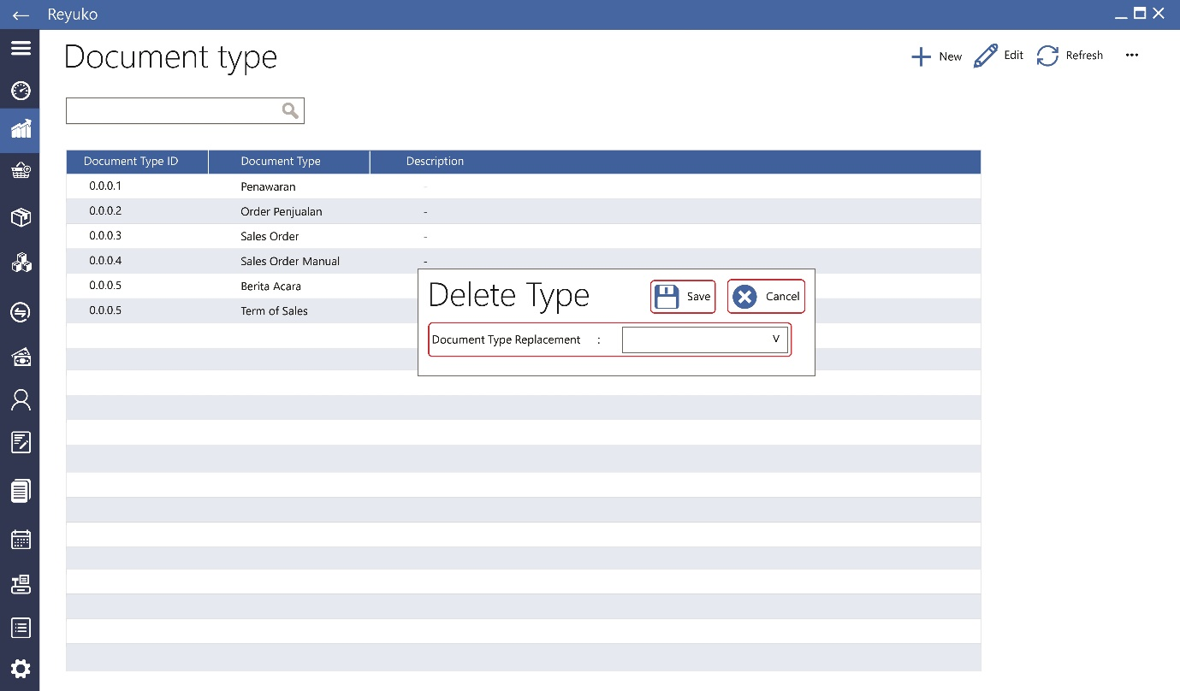

1. Button “save”, Save delete type of document, during deletion user will be asking the replace of document type when thera are document being assign to the respective document. When there are no document assignt to the type, deletion happen directly
2. Button “cancel”, cancel process
3. dropdown “document type replacement”, : list of document type

3. Document

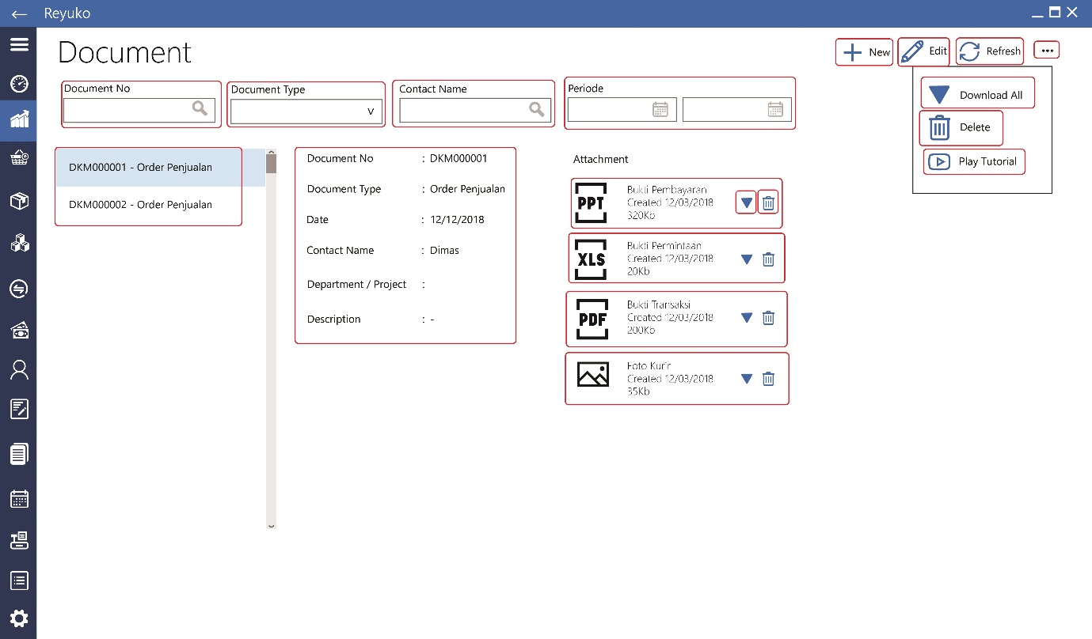

B

A

17

16

15

B

A

14

13

12

11

10

9

8

7

6

5

4

3

2

1

Document a group of 4 attach files. The porpose of this document is managing digital document of the customer. The file can be anything, but the support viewer extension is limited to office document, pdf, and jpg.

1. Field “search document no.”, search document base on document number
2. Dropdown “document type”, search document base on document type
3. Field “search contact name”, search document base on contact name
4. Field “periode”, search document base on date
5. Start date (date picker)
6. End date (datepicker)
7. Button “new”, new document
8. Button “edit”, edit document
9. Button “refresh”, refesh list (optional if needed)
10. Button “…”, more menu
11. Button “download all”, dowloand all file from current open document
12. Button “delete”, delete document, which means also delete all the file
13. Button “play tutorial”, play tutorial for document
14. Side list, list of the document: all document or base on query
15. Content detail, property of the document : number,type, date,contact, project/department, and desciption
16. File “A”, 1st file attachment, the display will be filename plus file type icon in the background (PPT,PDF,XLS,JPG,DOC)
17. Button download : download the file
18. Button delete : delete the file
19. File “B” 2nd file attachment
20. File “C” 3rd file attachment
21. File “D” 4th file attachment

3.1. Document (create new)

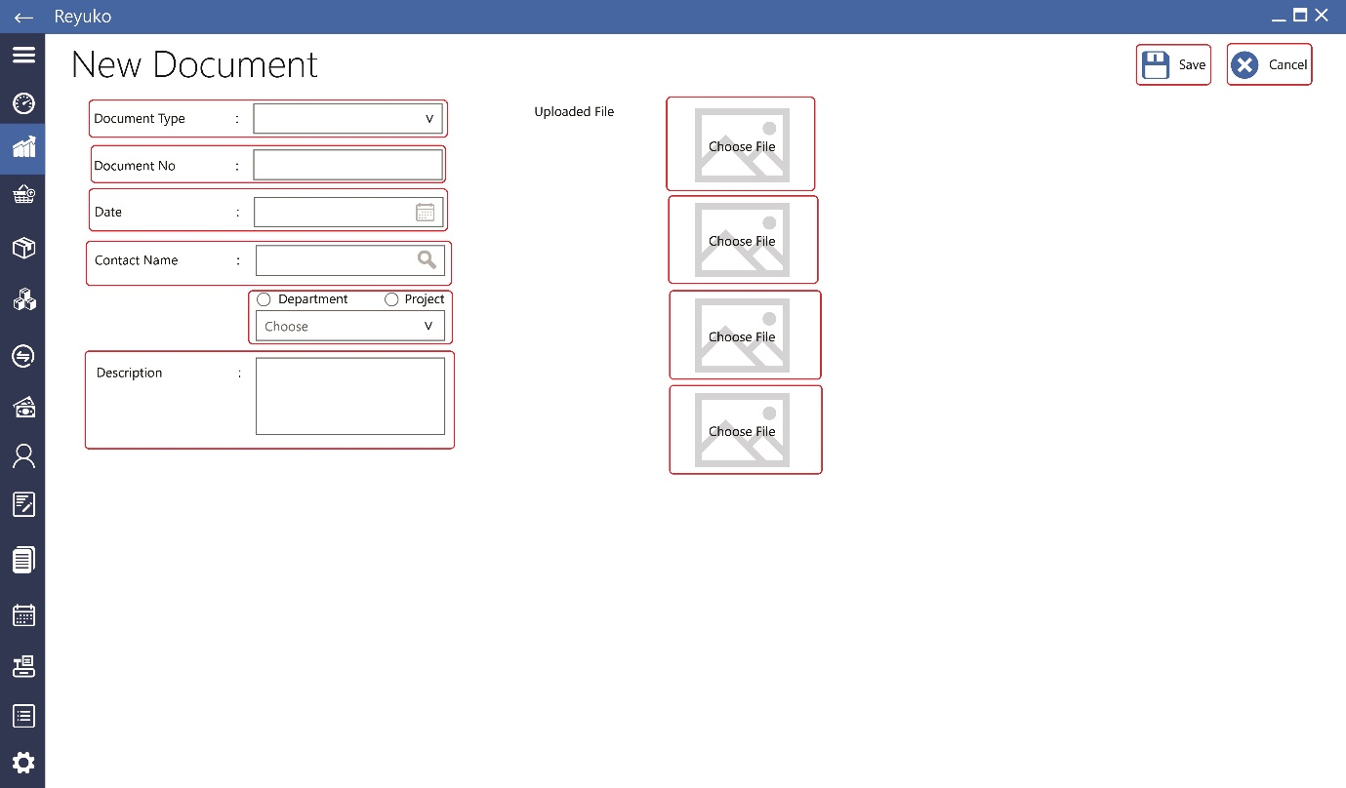

12

11

10

9

8

7

6

5

4

3

2

1

1. Button “save”, save document
2. Button “cancel”, cancel process
3. dropdown “document type”, display and select document type
4. Field “document no”, document number, unique, rejected if the number has been use, the field can use all the character. If not being fill by user, system will fill with document id
5. Field “date”, date of the document, by default is using entry date, can be replace by user
6. Field search “contact name”, entry contact name using ajax, if lense button hit will triger query to contact (all contact type customer, user, and vendor). The result being display as list below the form. This is mandatory field.
7. Radio button + dropdown , option between department and project. Project and department act as document tag. The dropdown will list department or project base on option being choose. Not mandatory field.
8. Field “description”, description field. Not mandatory field.
9. Upload file A : attach file
10. Upload file B : attach file
11. Upload file C : attach file
12. Upload file D : attach file

Document table

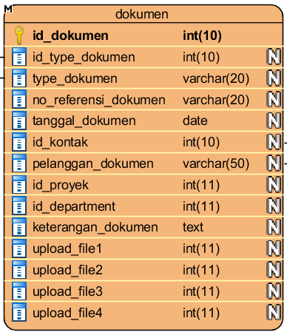

9

10

12

11

8

3

6

7

5

4

3.2. Document (edit)

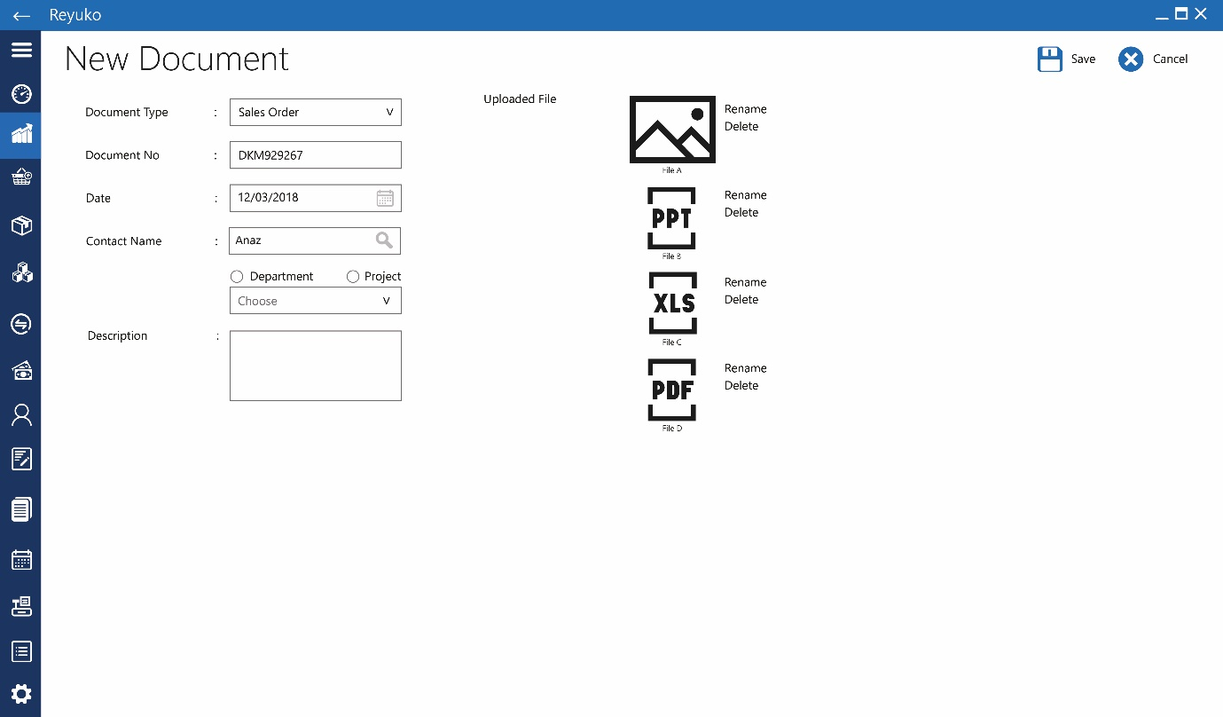

2

1

*open current data

~~1. button “rename”,~~

2. button “delete”, delete attach file

3.3. Document (preview)

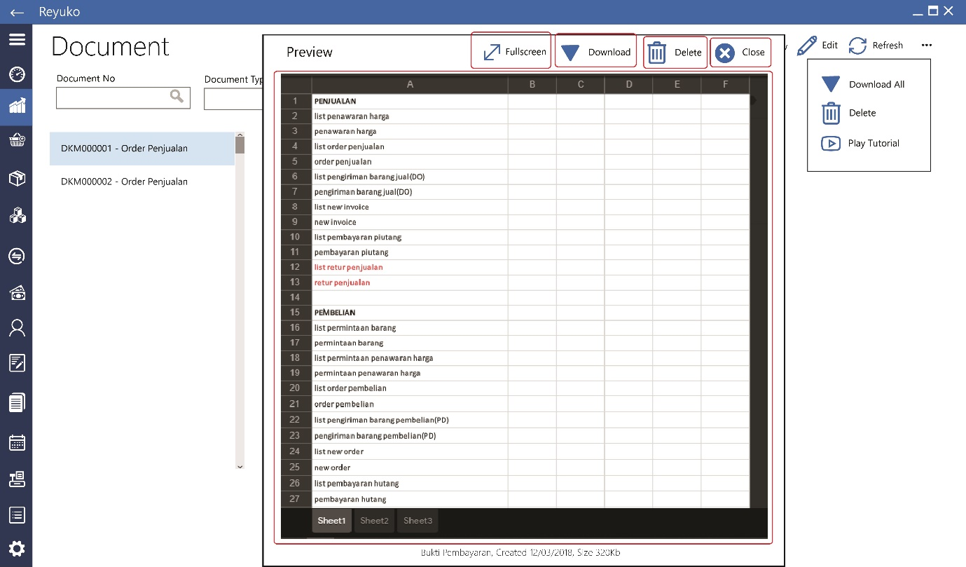

5

4

3

2

1

Is A pop up when user click file attached. The support documemt is , office document (powerpoint, excel,word, jpg picture, and pdf document)

1. Button “fullscreen”, switch to full screen mode from pop up mennu
2. Button “download”, download the file
3. Button “delete”, delete the file
4. Button “close”, close the preview
5. Content preview : the preview space
6. Notes Type

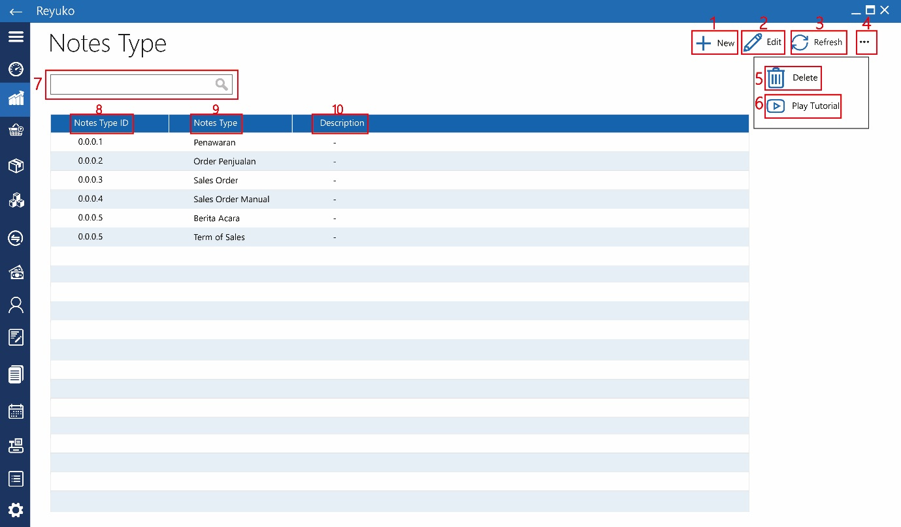

1. Button “new”,
2. Button “edit”,
3. Button “refresh”,
4. Button “…”, more menu
5. Button “delete”,
6. Button “play tutorial”, play related video tutorial
7. Field “search”,

Table Information

1. kolom “notes type id” :
2. kolom “notes type” :
3. kolom “description” :
   1. Notes Type (create new)

Note type has 2 function categories and templates

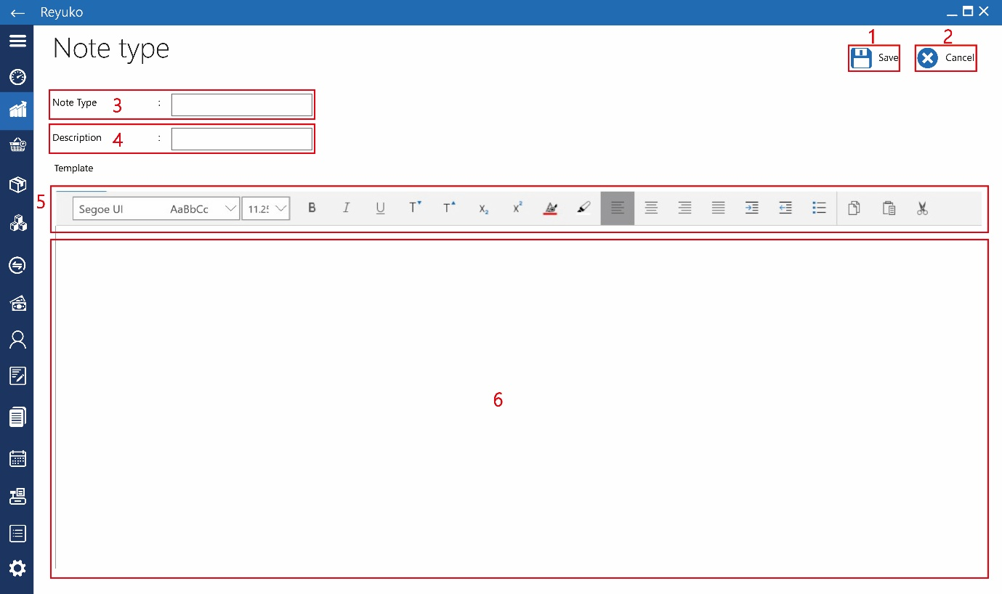

1. Button “save”, save type
2. Button “cancel”, abort process
3. Field “note type”, text, 64 character, unique, reject if there’s a duplication
4. Field “description”, text 255 character
5. Panel “toolbar”, standard rich text editing from microsoft
6. Field “text area”,

|  |  |  |
| --- | --- | --- |
| field table | table | remarks |
|  | id_note_type | Id unique |
| Note type | note_type |  |
| description | keterangan |  |
|  | template | Rich text format, support table |

* 1. Notes type (delete)

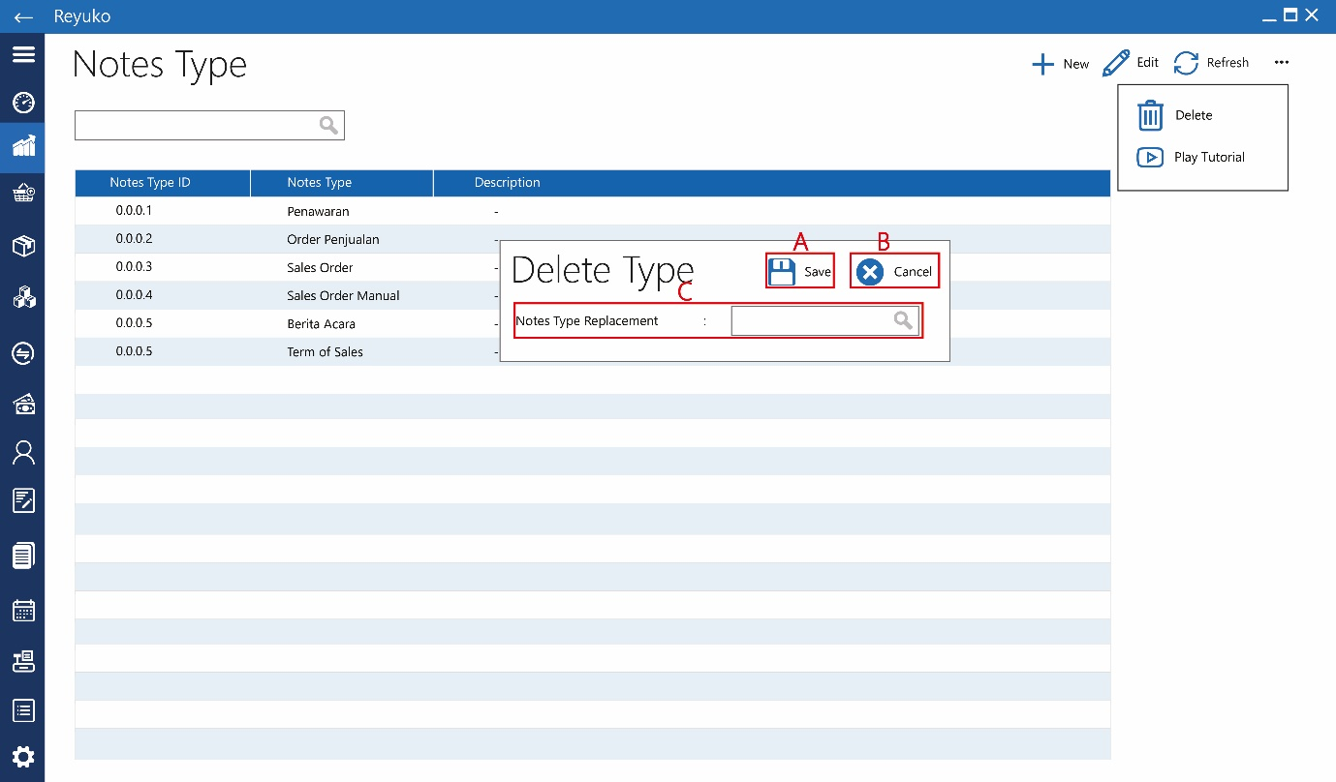

1. Button “save”, save deletion, contact type can be deleted but need to assign note with the type to other type or default (blank)
2. Button “cancel”, abort
3. Field search “notes type replacement”, search other type
4. Internal notes

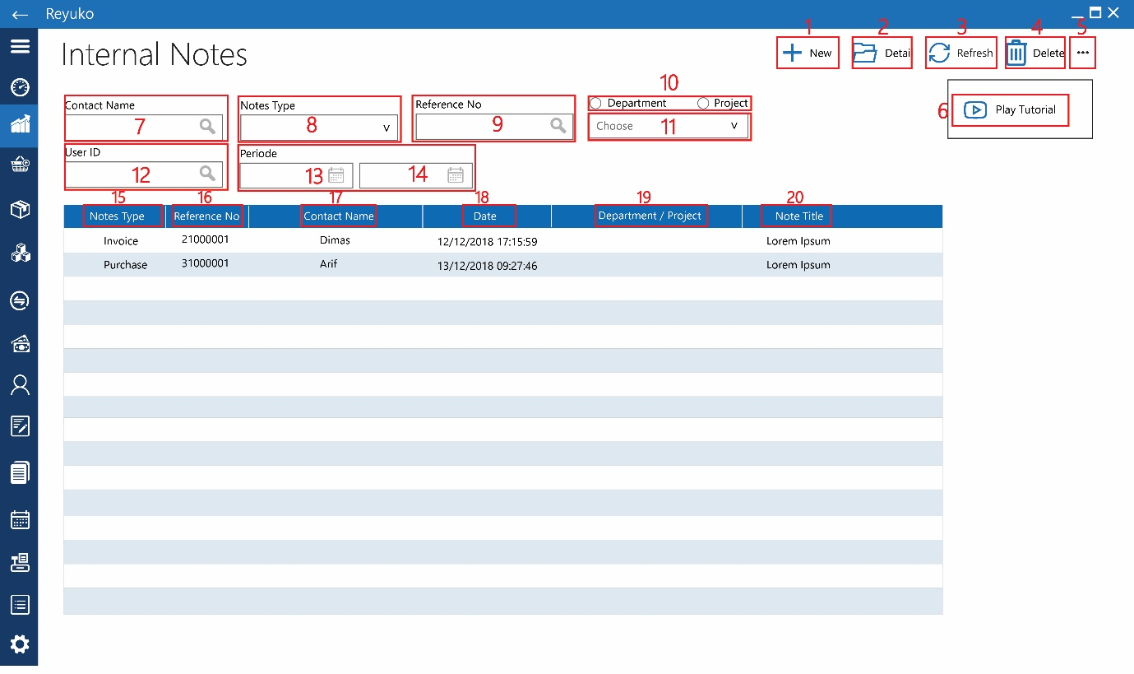

1. Button “new”, new note
2. Button “detail”, open selected note, same with double click
3. Button “refresh”, update query search (depend on the programing)
4. Button “delete”, deleted selected note, multiple select with control and shift
5. Button “…”, more menu
6. Button “play tutorial”,
7. Field search “contact name”, search contact on the note
8. Dropdown “notes type”, pull down look up from note type
9. Field search “reference No”, text 32 character, unique, reject duplication
10. Radio button “department/project”, choose between project and department
11. Dropdown “department/project”, look up to department / project table base on the radio button
12. Field search “user ”, look up to contact/employee table
13. Datepicker “start periode”, standard
14. Datepicker “end periode”, standard

Table Information : the same with query

1. kolom “notes type” :
2. kolom “reference no” :
3. kolom “contact name” :
4. kolom “date” :
5. kolom “department/project” :
6. kolom “note title” :
   1. internal notes (create new)

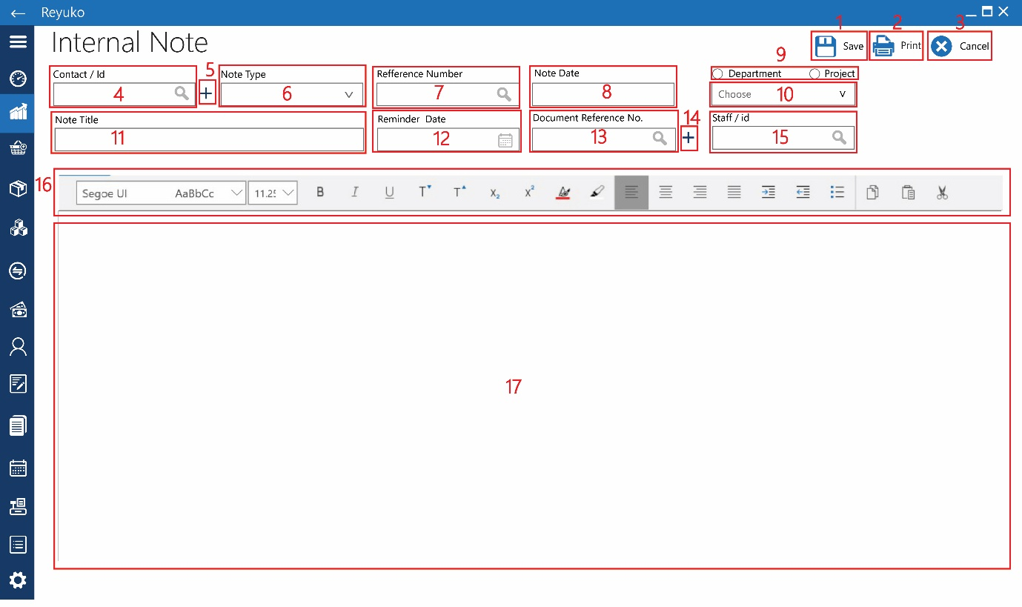

1. Button “save”, save note
2. Button “print”, triger pop up
3. Button “cancel”, abort
4. Field search “contact / id”, look up to contact (vendor, customer, employee)
5. Button “+”,triger button add contact menu, before that ask which contact : customer, employee, vendor
6. Dropdown “note type”, look up note type table, after selection , fill “16” area with template
7. Field search “reference number”, look up to document table
8. Date picker “note date”, pull down date picker
9. Radio button “department/project”, choose between project / dept
10. Dropdown “department/project”, look up to department / project table base on the radio button
11. Field “note title”, text, 64 character
12. Date picker “remember date”, pull down date picker, the date will be registered as notes to calendar
13. Field search “document reference no”, look up to document table, pull down list of document number.
14. Button “+”,
15. Panel “toolbar”, standar Microsoft rich format text tool
16. Field “text area”, typing area

|  |  |  |
| --- | --- | --- |
| field table | table | remarks |
|  | id_internal_note | Unique id |
| Contact/id | id_kontak |  |
|  | nama_kontak |  |
| Note type | id_note_type |  |
|  | note_type |  |
| Reference number | no_referensi |  |
| Note date | tanggal |  |
| project | id_proyek |  |
| department | id_departemen |  |
| title | judul |  |
| Reminder Dare | tanggal pengingat |  |
| Document Reffrence number | id_dokumen |  |
|  | no_referensi_dokumen |  |
|  | konten |  |

* 1. Internal notes (preview)

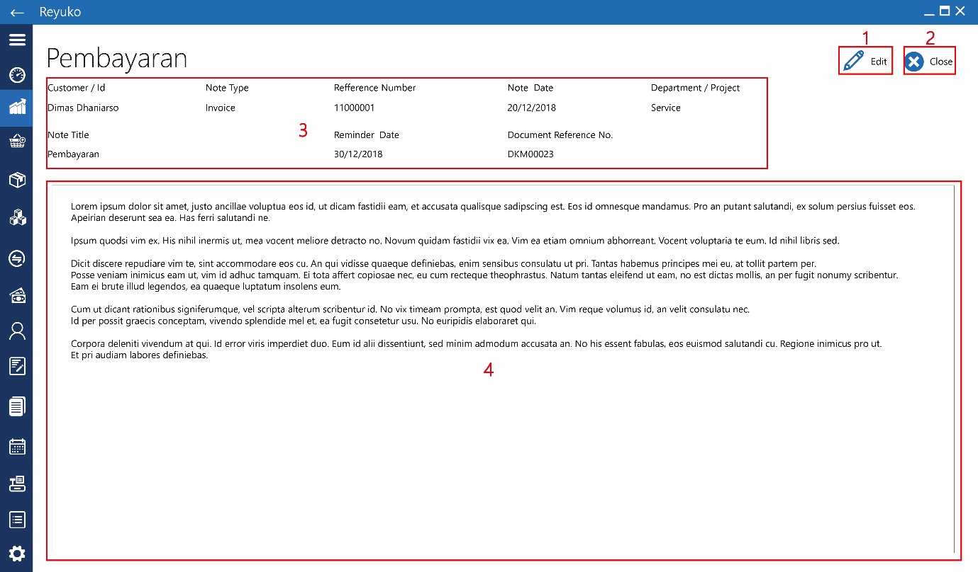

1. Button “edit”,
2. Button “cancel”,
3. Detail data
4. Content data